Problem Chosen: Smart Safety and Assistance System for Sanitation Workers of Solapur Municipal Corporation

Problem Definition
Problem context
Solapur Municipal Corporation (SMC) faces a critical worker-safety and operational governance challenge in its sanitation ecosystem. While the city has expanded its underground drainage network to approximately 246.14 km and is planning additional extensions, nearly 49% of the population continues to depend on on-site sanitation systems.
A major spatial and infrastructural constraint exists: over 220 slum settlements contain narrow lanes inaccessible to standard mechanized cleaning fleets. This limitation significantly reduces the practical deployment of remote tools and forces partial dependence on hazardous manual entry into confined spaces.
- Sanitation workers are frequently exposed to:
- Toxic and explosive gases such as H₂S and CH₄
- Oxygen-deficient environments leading to suffocation
- Long-term infection risks
- Structural instability or chamber collapse
- Sudden flooding during blockage clearance
These hazards are compounded by the absence of real-time environmental monitoring, lack of automated alert mechanisms, and limited supervisor visibility during field operations. In practice, workers often assess gas presence through unsafe informal methods due to absence of technological safeguards.
Despite enforcement of the Prohibition of Manual Scavenging Act and mechanization initiatives under national sanitation missions, complete elimination of hazardous manual exposure has not yet been achieved.
Core Problem Statement: SMC lacks an integrated, real-time, technology-enabled safety, monitoring, and assistance system that proactively reduces hazardous manual exposure, prevents life-threatening confined-space risks, enhances worker dignity, and improves operational efficiency in sanitation governance.

Objectives
- Proactive Life Safety: Reduce unauthorized or blind manual sewer entry by ≥70% in pilot zones within 90 days by enforcing monitored workflows.
- Real-Time Hazard Monitoring: Ensure ≥90% of active sanitation operations are supported by continuous gas detection (H₂S, CH₄, CO) and oxygen monitoring.
- Explosive & Suffocation Risk Prevention: Detect toxic/explosive gas thresholds and oxygen deficiency prior to or during entry and trigger automated alerts within ≤5 seconds of threshold breach.
- Emergency Response Assurance: Enable distress alerts with supervisor acknowledgement within ≤60 seconds and escalation protocol activation within ≤5 minutes.
- Supervisor Operational Visibility: Provide centralized monitoring for 100% of high-risk sanitation tasks to eliminate blind field operations.
- Mechanization Optimization: Increase utilization of available mechanized equipment to ≥75% in pilot areas to minimize manual fallback operations.
- Worker Dignity & Compliance Enforcement: Achieve 100% digital authorization logging for all high-risk entries to prevent informal unsafe practices and protect worker dignity

Constraints
HARD Constraints
- Legal Compliance: Must align with the Prohibition of Manual Scavenging Act and worker safety mandates.
- Environmental Durability: All wearable and sensing devices must operate reliably in wet, corrosive, and confined sewer environments. Minimum IP68 rating required for deployment feasibility.
- Spatial Accessibility: Portable remote inspection tools must navigate narrow slum lanes inaccessible to large fleets. Maximum device width ≤ 0.5 meters for maneuverability.
- Connectivity Reliability: Must function in underground and signal-obstructed environments using high-penetration communication protocols.
- Cost Feasibility: Deployment must remain financially viable within SMC budgetary limits. Target wearable hardware cost ≤ INR 5,000 per worker for scalable adoption.
- Integration Compatibility: Must integrate with existing Smart City ICCC infrastructure without duplicating command systems.
SOFT Constraints
- Minimal Additional Manpower: Should not require significant new hiring for operation.
- Battery & Maintenance Practicality: Minimum 12-hour battery life and ≥30-day calibration stability to ensure operational continuity.
- Worker Accessibility: Interfaces must support localized language usage (Marathi) and minimal digital literacy requirements.

Functions
- The system shall continuously detect ambient concentrations of hazardous and explosive gases (H₂S, CH₄, CO) and oxygen levels and trigger local audio-visual alerts upon threshold breach.
- The system shall transmit real-time telemetry (gas levels, location data, emergency signals) to a centralized supervisor dashboard to ensure operational visibility.
- The system shall digitally authorize and log all high-risk manhole entries through mandatory supervisor verification to functionally block unsafe manual descent.
- The system shall enable remote visual inspection of deep pipelines prior to human intervention to detect structural instability, blockages, and flooding risks.
- The system shall automatically evaluate environmental parameters and contextual risk indicators to assign a dynamic risk score before task execution.
- The system shall provide immediate SOS capability and automated escalation for emergency situations.
- The system shall record an immutable timeline of sensor data, authorization logs, and emergency events for audit and post-incident analysis.
- The system shall support mechanized equipment allocation tracking to minimize manual exposure and improve operational efficiency.

Early-Stage Solution Architecture
Problem Chosen: Smart Safety and Assistance System for Sanitation Workers of Solapur Municipal Corporation

List of subsystems
SI.NO | Subsystem name | Functionality
1 | Field Sensing (Guard+Probe)
1.a | VeerGuard – Wearable Safety System | - Continuously measures H₂S, CH₄, CO and O₂ levels during sewer operations.  - Generates local audio-visual alerts when thresholds are breached.  - Transmits gas telemetry, GPS location, battery status and SOS signal to VeerEdge.  - Provides real-time personal safety monitoring for each स्वच्छता वीर.
1.b | VeerProbe – Smart Pre-Entry Inspection Kit | - Performs remote gas and visual inspection before any manual entry.  - Detects toxic gases, water level, structural condition and depth.  - Sends inspection data to VeerEdge and VeerVision for hazard analysis.  - Reduces blind entry risk and supports safe decision-making.
2 | Robotic & Fleet (Crawler+FleetEye)
2.a | VeerCrawler – Portable Robotic Inspection Unit | - Conducts remote inspection in high-risk, deep or narrow sewer segments.  - Streams live video to VeerVision for AI-based hazard detection.  - Logs runtime and deployment status via FleetEye.  - Supports machine-first enforcement policy.
2.b | FleetEye – Machine Tracking & Utilization System | - Tracks GPS location, runtime hours and availability of mechanized cleaning vehicles.  - Verifies machine attempt before manual entry in medium/high-risk tasks.  - Enforces machine-first policy.  - Provides deployment status to SwachhCommander Dashboard.
3 | Field Communication and power (VeerEdge) | - Collects LoRa telemetry from VeerGuard and VeerProbe.  - Transmits encrypted data to cloud via 4G.  - Buffers data during network instability.  - Supplies charging interface to VeerCrawler from vehicle battery.
4 | Data & Intelligence Core (Registry+Risk+Vision+Plan)
4.a | VeerRegistry – Digital Sewer Asset Registry | - Maintains database of all manholes and sewer assets with unique ID.  - Stores GPS location, depth, cleaning history, gas logs and incident records.  - Serves as foundational data layer for VeerRisk and VeerPlan.  - Integrates with existing GIS infrastructure.
4.b | VeerRisk – Dynamic Risk Scoring Engine (AI-Assisted) | - Computes risk score (0–100) for each sanitation task.  - Analyzes zone type, gas history, flood risk, cleaning delay, and industrial exposure.  - Enforces machine-only cleaning for high-risk scores.  - Provides risk classification to VeerPass and Dashboard.  - Uses AI-assisted prediction with rule-based fallback.
4.c | VeerVision – AI-Based Camera Hazard Detection | - Processes inspection camera feeds from VeerProbe and VeerCrawler.  - Detects water turbulence, chemical foam, blockage density and structural cracks.  - Generates hazard alerts with confidence score.  - Provides AI output to VeerRisk and Dashboard.
4.d | VeerPlan – Preventive Maintenance Scheduling Engine | - Identifies high-risk and overdue manholes.  - Generates preventive cleaning tasks before complaints occur.  - Prioritizes assets based on risk classification and history.  - Shifts sanitation operations from reactive to proactive.
5 | Authorization & Governance (Pass+BlackBox+Dashboard)
5.a | VeerPass – Digital Entry Authorization Mandate | - Controls manual sewer entry through digital approval workflow.  - Verifies task existence, risk score, PPE checklist and machine attempt.  - Requires supervisor approval before descent.  - Prevents unauthorized manual entry.  - Maintains authorization logs for audit.
5.b | VeerBlackBox – Incident Logging & Replay System | - Records gas telemetry, authorization logs, AI alerts and machine usage timeline.  - Reconstructs minute-by-minute incident replay.  - Supports investigation, training and institutional accountability.
5.c | SwachhCommander Dashboard – ICCC Extension | - Displays live gas telemetry, worker location and machine status.  - Shows risk heatmaps and AI hazard alerts.  - Provides supervisor approval interface for VeerPass.  - Integrates into existing ICCC infrastructure without creating new control room.
6 | External Integration (Grievance) | - Receives sanitation complaints via portal, WhatsApp bot or toll-free number.  - Forwards complaint data to VeerRegistry, VeerRisk and VeerPlan.  - Enables complaint tracking through SwachhCommander Dashboard.  - Serves as external trigger source for sanitation tasks.

Subsystems Interaction matrix

From \ To | 1. Field Sensing | 2. Robotic & Fleet | 3. Field Comm & Power | 4. Data & Intelligence Core | 5. Authorization & Governance | 6. External Integration
1. Field Sensing | — | Data: inspection request/assist; Spatial: operator uses probe at site. | Data: LoRa telemetry — H₂S/CH₄/CO/O₂ (ppm), GPS, battery, SOS; Data: probe images. | Data: telemetry & inspection → registry + risk input. | Data: immediate alert to supervisor; Data: PPE-check result; Material: PPE handover recorded. | Data: (via Core) asset ↔ complaint match.
2. Robotic & Fleet | Data: robot inspection summary → sensing operator. | — | Data: live video + telemetry to gateway; Energy: robot charging state (12V DC) reported; Spatial: robot stowed/transported on vehicle. | Data: inspection frames → AI; Data: runtime & GPS → registry/plan. | Data: machine-attempt logs for authorization; Spatial: human lowers robot into manhole. | Data: (via Core) grievance-driven dispatch info; Material: equipment delivered for investigation.
3. Field Comm & Power | Data: config/threshold updates pushed to devices | Data: relays commands to robot; Energy: provides charging interface (12V DC) to robot when docked | — | Data: forwards encrypted telemetry & video JSON → Core; Data: buffer/retransmit on outage; Energy: reports gateway power status to Core. | Data: event sync & telemetry replay requests → BlackBox; Data: timestamp alignment. | Data: forwards complaint attachments → Core.
4. Data & Intelligence Core | Data: risk/advisory & PPE checklist → field UI | Data: machine-mandate flag; scheduling & dispatch advisories → fleet | Data: ingestion ACKs; config updates → gateway | — | Data: risk classification, scheduled tasks, AI alerts → Dashboard; Data: logs → BlackBox | Data: ingests complaints; Data: reprioritizes plan & risk.
5. Authorization & Governance | Data: supervisor approval / PPE confirmation → worker UI; Material: authorization slip / PPE issuance record | Data: approval/deny; Data: require machine-attempt verification for high risk; Spatial: permit worker entry only after approval | Data: request telemetry replay via gateway when required | Data: authorization audit records → Core (for linking to asset history) | — | Data: complaint status & resolution updates → citizens; Data: BlackBox records complaint lifecycle
6. External Integration | Data: complaint (GPS + issue type) mapped to asset via Core | Data: complaint may request robotic inspection dispatch (via Core) | Data: complaint attachments uploaded to Core via gateway | Data: complaint metadata → Core used by Risk & Plan for reprioritisation | Data: Dashboard receives complaint notification; Data: BlackBox stores complaint events | —

Architecture Diagram

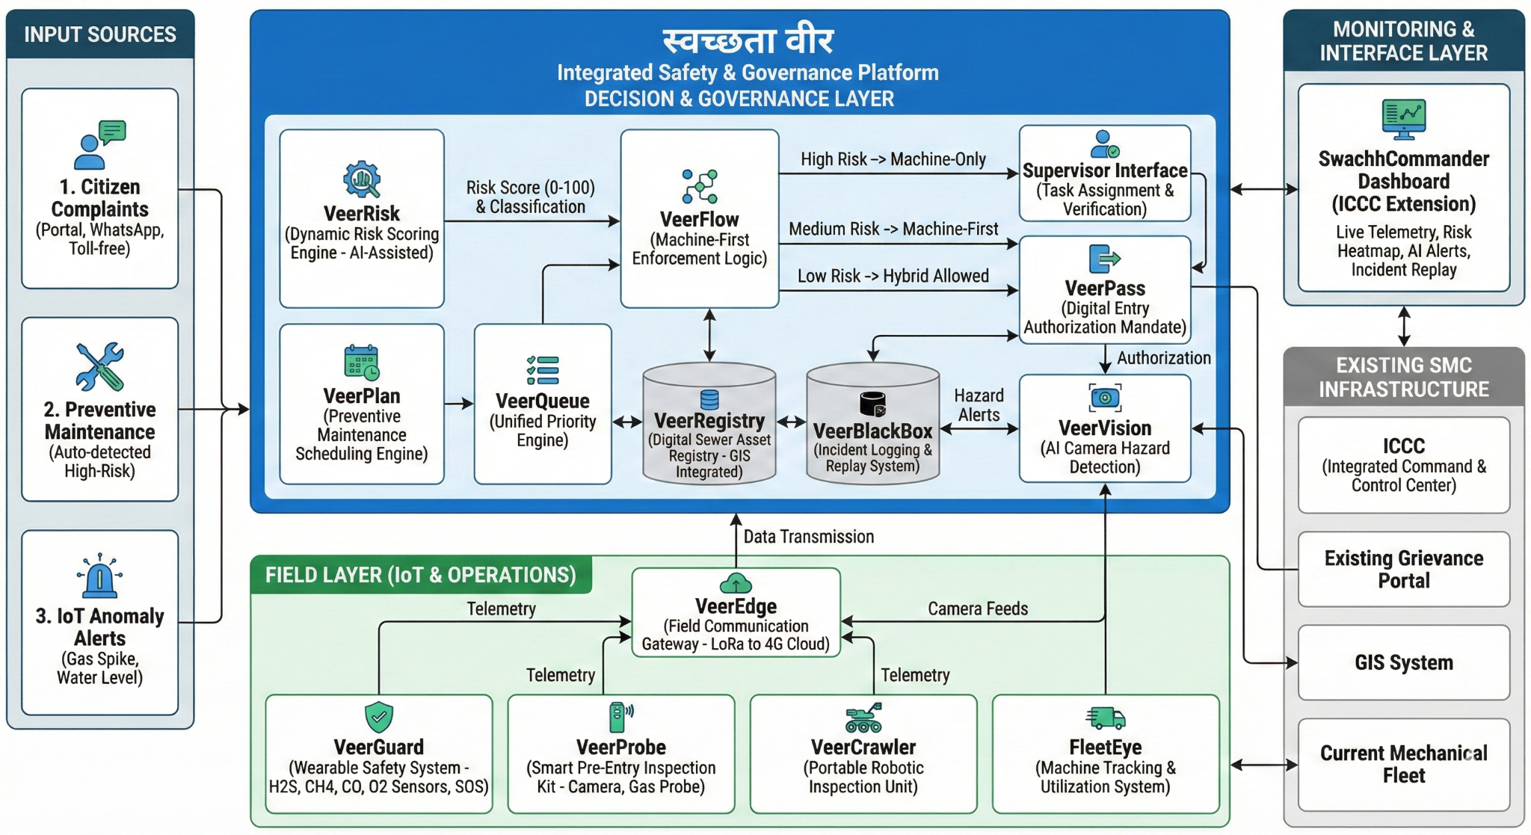

Our Team Work : Aarohan Samved Work

Team Information
Team name: : Aarohan |  |  | Institute code: 06146
Institute name: MIT Academy of Engineering, Alandi, Pune
City: Pune |  |  | State: Maharastra
Mentor Details
Mentor name: Mr. Amar H More
Contact number: +91 98509 78452 |  |  | Email: ahmore@comp.maepune.ac.in
Participant Details
SN | Participant name | Program | Sem | Contact number | Email
1 | Tushar Kaldate | Computer | 4th | 7798760700 | tusharkaldate110@gmail.com
2 | Shreyas Salunkhe | Computer | 4th | +91 832 923 1523 | Shreyassalunkhe811@gmail.com
3 | Pranshu Bobade | Computer | 4th | +91 89830 74636 | pranshubobade@gmail.com
4 | Aradhya Avhad | Computer | 4th | +91 80070 26587 | avhadaradhya@gmail.com
5 | Sheel Gaikwad | Computer | 4th | +91 70575 34508 | gaikwadsheel@gmail.com
Note: The above details will be used for certificate generation. Please ensure accuracy.
Declaration
We hereby declare that the work titled “Smart Safety and Assistance System for Sanitation Workers of Solapur Municipal Corporation” submitted for SAMVED-2026 is the original outcome of our team’s efforts.
The work has been carried out by us under the guidance of the undersigned mentor and is neither copied from any source nor generated using artificial intelligence (AI) tools.

Place: Pune
Date: 19/02/2026
Team Leader Name: Tushar Kaldate
_______________________________________
Mentor Name: Mr. Amar H More
_______________________________________

